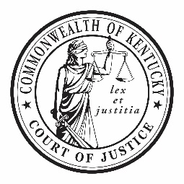  Jefferson County Specialty Court Staff  Robert Brossart  Regional Supervisor  Wayne Crabtree  Statewide Clinical Coordinator  ShaiAnne Moorman  Tearia Thompson -VTC  Vijay Blevins  Matthew Winner  Case Manager  Tishara Watters  Project Coordinator -Mental Health Court  Eric Starnes  Administrative Support  Officer Shane Justis  Louisville Metro Police Department  Thank you  A special thanks to family, friends, sponsors, our partners in treatment, Jefferson County District Court, Jefferson County Circuit Court, and the Administrative Office of the Courts, Community Partners, as well as the many behind the scenes personnel who make this program a success for our graduates. |  |  | 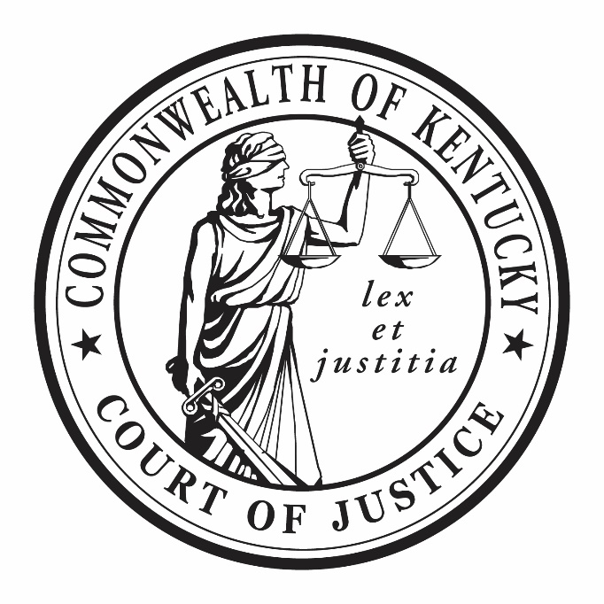

Specialty Courts

Jefferson County

Drug Court Graduation

Wednesday, October 18, 2023
3:00 PM

Jefferson County Drug Court  2023 Graduates  Hon. Annie O’Connell  Nicola H.  Chad G.  Michael A.  Nicole S.  Hon. Stephanie Burke  Gina M.  Jimmy B.  Sarah E.  Hon. Ann Bailey Smith  Justin F.  Paige M.  Tracy B.  Jerimey L.  Tony M.  Paige M. |  | Event Program  Welcome  Judge Ann Bailey Smith - Circuit Court  Speaker  Tara Hyde - People Advocating Recovery (PAR)  Presentation of Certificates  Hon. Josephine Buckner - District Court  Hon. Annie O’Connell - Circuit Court  Hon. Stephanie Burke - District Court  Hon. Ann Bailey Smith - Circuit Court  Keep On Keeping On Award  Hon. Josephine Buckner  Closing Remarks  Robert Brossart - Regional Supervisor

